1、identify the concepts

|  |  |  |
| --- | --- | --- |
| Responsibility description | Type | Concept name |
| See the schedule and jump to the adding interface | D | ScheduleDisplay |
| The editing interface is a complete schedule, click on the corresponding box, you can enter to view detailed schedule information | D | ScheduleEditor |
| Click the box that has not been edited to add a new schedule | D | ScheduleAddition |
| Click the box that has not been edited to set an alarm | D | AlarmSetter |
| Start to count down and alarm at a certain time | D | Timer |

2、design sequence diagram

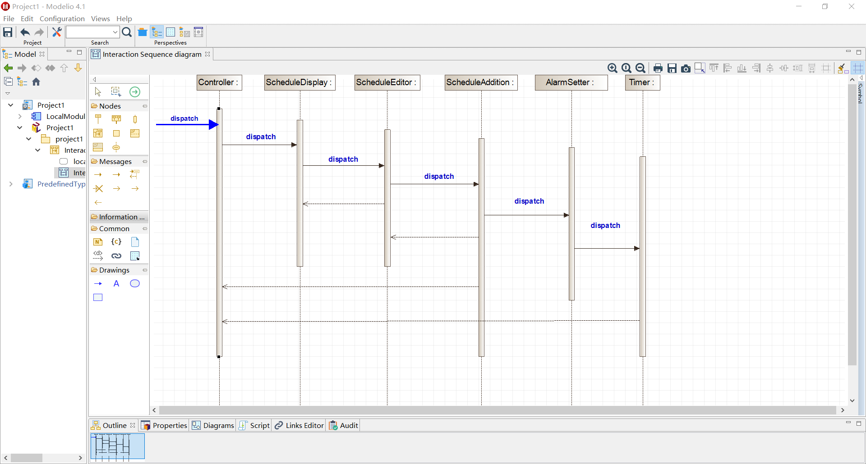

3、class diagram

